
Green University of Bangladesh
Department of Computer Science and Engineering (CSE)
Faculty of Sciences and Engineering
Semester: (Fall, Year: 2025), B.Sc. in CSE (Day)

Lab Report NO: 01
Course Title: Microprocessors, Microcontrollers, and Embedded System Lab
Course Code: CSE 304
Section: 232-D1

Lab Experiment Name: Take an input from user in Celsius. Convert it to Fahrenheit using the following expression and store in a F variable: °F = °C×9/5 + 32- 1

Student Details

Name |  | ID
1. | Ashab Uddin | 232002274

Lab Date : 15/10/2025
Submission Date : 22/10/2025
Course Teacher’s Name : Jarin Tasnim Tonvi

Lab Report Status
Marks: ………………………………… Signature:.....................
Comments:.............................................. Date:..............................

TITLE: Take an input from user in Celsius. Convert it to Fahrenheit using the following expression and store in a F variable: °F = °C×9/5 + 32- 1
1. INTRODUCTION
This program addresses the fundamental engineering problem of converting temperature values from Celsius to Fahrenheit. The architectural constraints of the 8086 microprocessors, notably the absence of a dedicated Floating-Point Unit (FPU), necessitate that all arithmetic operations be executed using integer logic. The accompanying assembly language implementation demonstrates the proper methodology for realizing the conversion formula °F = (°C × 9/5) + 31. This is achieved through precise management of CPU registers and sequential integer operations for multiplication, division, and addition to yield a correct integer result. The code serves as a salient illustration of data manipulation and input/output handling within the resource-constrained environment characteristic of 8086 systems.

2. OBJECTIVES
- To accurately implement the conversion formula: °F = °C×9/5 + 32- 1 in 8086 assembly.
- To handle all necessary user interaction and data flow.
- To write optimized and efficient 16-bit code.
3. PROCEDURE
The code performs the conversion using an integer-only approximation of the formula °F = °C×9/5 + 32- 1.
- Input: Prompts the user to enter a Celsius digit (0-9). The input ASCII character is read and converted to its numerical value (C).
- Calculation:
  - C is multiplied by 9 (C× 9).
  - The result is divided by 5 (C× 9) / 5).
  - 31 is added to the quotient (equivalent to + 32 - 1) to get the final integer Fahrenheit value (F).
- Output: The two-digit Fahrenheit result (F) is prepared for display using the AAM instruction (which separates F into its tens and units’ digits). Each digit is converted back to its ASCII character and printed to the console.

4. IMPLEMENTATION

Source Code:
.MODEL SMALL
.STACK 100H

.DATA
MSG1 DB 'Enter Temperature in Celsius (0-9): $'
MSG2 DB 0AH, 0DH, 'Temperature in Fahrenheit is: $'
NINE DW 9
FIVE DW 5

.CODE
MAIN PROC
; Initialize Data Segment
MOV AX, @DATA
MOV DS, AX

; --- User Input ---
; Print input prompt message
LEA DX, MSG1
MOV AH, 9
INT 21H

; Read a single character from the user
MOV AH, 1
INT 21H

; Convert ASCII digit to a number
SUB AL, '0'
MOV BL, AL

; --- Calculation: F = (C * 9 / 5) + 32 - 1
MOV AL, BL
MOV AH, 0

MUL NINE

DIV FIVE

ADD AL, 32
SUB AL, 1

MOV BL, AL

; --- Display Output ---
; Print the result message
LEA DX, MSG2
MOV AH, 9
INT 21H

; Prepare the Fahrenheit value for display
MOV AL, BL
MOV AH, 0
AAM

; Now AH has the tens digit and AL has the units digit
MOV CX, AX

; Print the tens digit
MOV DL, AH
ADD DL, '0'
MOV AH, 2
INT 21H

; Print the units digit
MOV DL, CL
ADD DL, '0'
MOV AH, 2
INT 21H

; --- Terminate Program ---
MOV AH, 4CH
INT 21H

MAIN ENDP
END MAIN

5. OUTPUT

Waiting for the INPUT

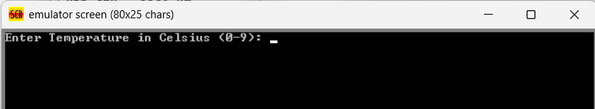

Show OUTPUT

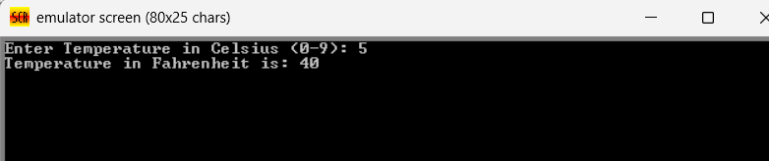

6. ANALYSIS AND DISCUSSION
This 8086-assembly program converts a single-digit Celsius temperature (C, from 0-9) to a Fahrenheit temperature (F) through three main phases. First, in the Input phase, it reads the ASCII digit C, converts it to its numerical value, and stores it in BL. Second, the Calculation phase attempts the conversion using integer arithmetic: C is multiplied by 9, the result is divided by 5 (truncating the remainder), and then 31 is added (via +32 - 1). This reliance on integer division and the use of the incorrect +31 constant means the resulting Fahrenheit temperature will be an inaccurate approximation. Finally, the Output phase uses the AAM instruction to separate the two-digit result F into its tens and units digits, converts these numerical digits back to ASCII characters, and prints them sequentially to the console before the program terminates.

.

